How to limit the computer in the LAN to access some websites through Website filter function?

Product line: wireless Question category: function configuration

Q：Why we need to configure the Website Filter?

A：In order to control the computer to have access to websites, you can use URL Filtering to allow the computer to have access to certain websites at fixed time and forbids it having access to certain websites at fixed time.

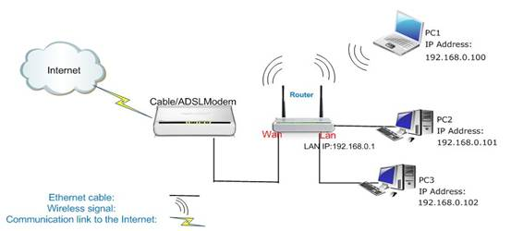

Steps are following:

1．Login the management page of the router.

2．Click the Parental Control-Website Filter and you will find the page as below. There are two options (Disable, Forbid only). The URL filter is disable default.

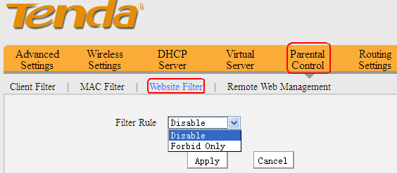

For example, if you want to block the computers whose IP Address is 192.168.0.100 - 192.168.0.200 to access the websites that include Google from 8:00 to 18:00 every day. And the computer with other IP Address can access the website. You can set the router as the following picture.

